TRAFFIC DEMAND PREDICTION USING MACHINE LEARNING
Problem statement:
Traffic congestion has become a major challenge due to the increasing number of vehicles and changing road conditions. Existing traffic management systems cannot accurately predict future traffic demand. This project uses machine learning to analyze traffic and weather data for accurate traffic demand prediction. The system helps improve traffic management, reduce congestion, and support smart city transportation.

Contents:
- Introduction
- Objectives
- Literature Survey
- System Analysis
- Methodology
- Technologies and Tools Used
- Results and Evaluation
- Conclusion and Future Scope

1. Introduction
Traffic congestion is one of the major challenges in urban areas due to the continuous increase in vehicles and population. Predicting traffic demand helps in managing transportation systems efficiently and reducing congestion.
Machine Learning techniques can analyze historical traffic data and identify patterns to predict future traffic conditions. This project focuses on developing a Traffic Demand Prediction system that uses machine learning algorithms to forecast traffic demand based on previous data.
The system helps in improving traffic management, optimizing travel routes, and supporting smart transportation solutions.
2. Objectives
The main objectives of this project are:
- To analyze historical traffic data and identify traffic patterns.
- To preprocess and prepare traffic datasets for machine learning models.
- To develop a machine learning model for predicting future traffic demand.
- To improve traffic management by providing accurate traffic predictions.
- To evaluate the performance of the prediction model using suitable evaluation metrics.
- To build an efficient system that supports better transportation planning and decision-making.
3.Literature Survey
Traffic demand prediction has become an important area of research in intelligent transportation systems. Earlier studies used statistical methods to analyze traffic patterns and forecast future conditions. With the growth of Machine Learning, algorithms such as Linear Regression, Decision Tree, and Random Forest have been used to improve prediction accuracy. Recent research focuses on Deep Learning techniques to handle complex traffic data and real-time forecasting. Studies show that considering factors like time, weather, and road conditions helps in achieving better traffic prediction results. These approaches support efficient traffic management and help reduce congestion in urban areas.
4. System Analysis
Proposed System
The proposed system uses Machine Learning techniques to predict traffic demand based on historical traffic data. The system processes traffic information, identifies patterns, trains prediction models, and forecasts future traffic conditions. This helps in improving traffic management and supports efficient transportation planning.
Advantages of Proposed System
- Accurate traffic demand prediction
- Automated data analysis
- Reduces traffic congestion
- Improves transportation planning
- Supports smart city applications
5. Methodology
The methodology of the Traffic Demand Prediction system involves collecting, processing, and analyzing traffic data using Machine Learning techniques.
- Data Collection: Collect historical traffic data containing vehicle count, time, weather, and road information.
- Data Preprocessing: Clean and prepare the data by handling missing values and removing errors.
- Model Training: Train Machine Learning algorithms using the processed dataset.
- Prediction: Use the trained model to predict future traffic demand.
- Evaluation: Measure model performance using suitable evaluation metrics.

Exploratory Data Analysis (EDA)
Exploratory Data Analysis (EDA) is performed to understand the traffic dataset before training the machine learning model. It helps identify missing values, detect outliers, analyze feature distributions, and understand relationships between variables. Various graphs and charts are used to visualize the data and gain insights for better model development.
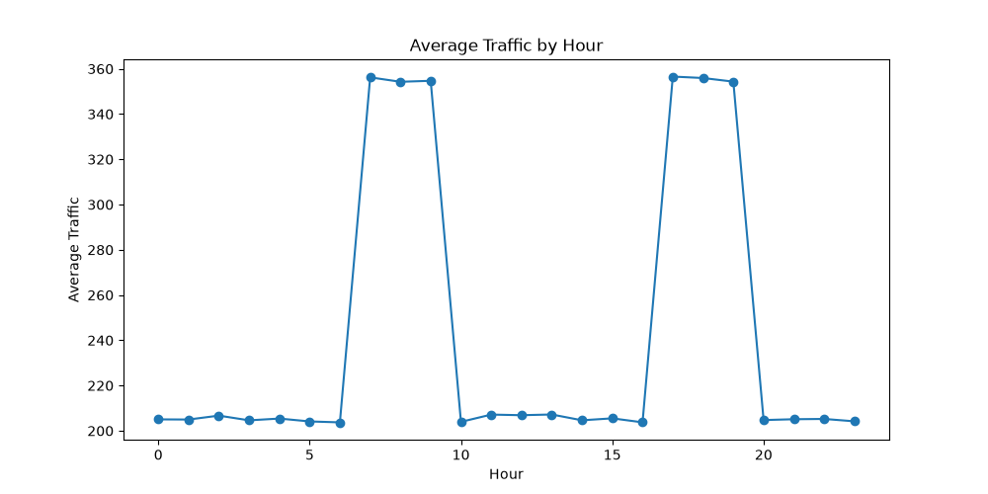Fig1: Average Traffic By Hour

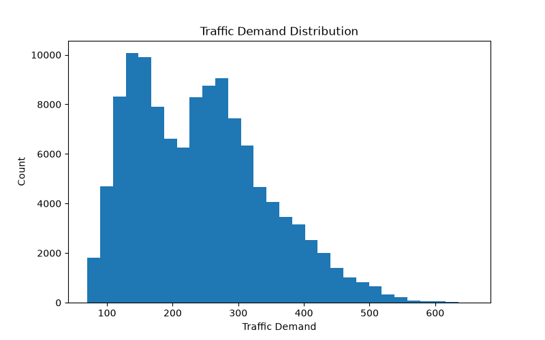
Fig2: Traffic Demand Distribution

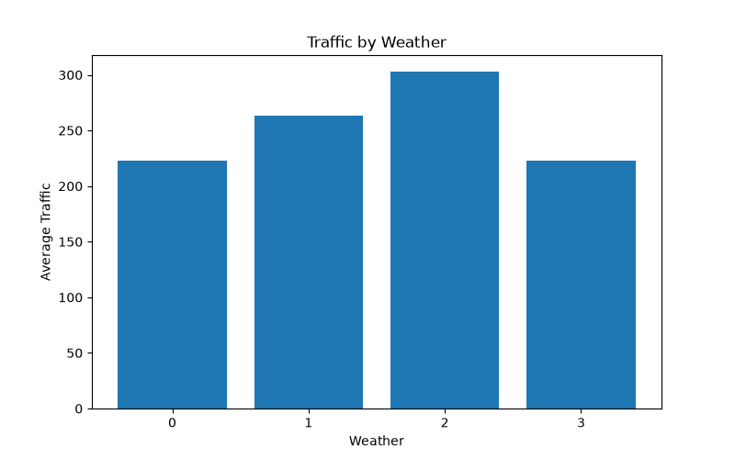
Fig3: Traffic By Weather
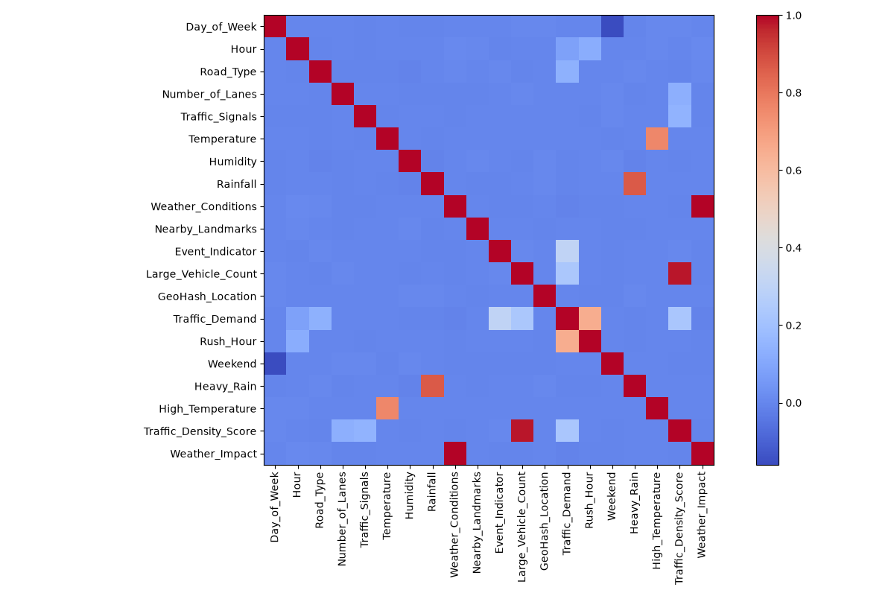
Fig4: Traffic By Weather

6. Technologies Used
- Programming Language: Python
- Development Environment: Visual Studio Code (VS Code)
- Machine Learning Library: Scikit-learn
- Data Analysis Libraries: Pandas and NumPy
- Data Visualization: Matplotlib and Seaborn
- Web Framework: Flask
- Dataset Format: CSV Files
- Version Control: Git (optional)

Results and Evaluation:

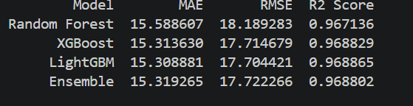

Conclusion and Future Scope:

